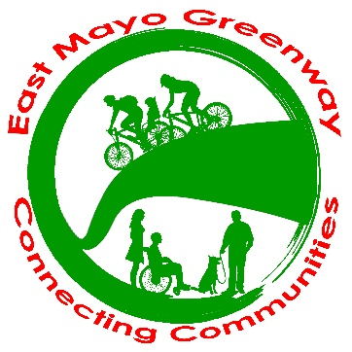 | Submission from East Mayo Greenway Group to Mayo County Council (hereafter MCC) in regard to Local Area Plan for the Ballina Town & Environs area  May 12th ^{th} 2021

This submission is being made on behalf of the 1235 members of the East Mayo Greenway Group (hereafter EMGG).

East Mayo Greenway Group. Who are we? What are our credentials? How many people support us in East Mayo?

EMGG was formed in 2019 after the Kiltimagh Greenway Group took the decision to rename itself to give a county wide focus to the campaign to utilize the closed railway which runs from Charlestown to Claremorris as a greenway until such time as a railway might be possible.

The group is currently arranging to register as a formal community group with Mayo County Council as part of the Public Participation Network, being part of the PPN will place the group on a level of recognized community status with MCC.

Our membership is defined as members of the East Mayo Greenway Group on Facebook the social media platform we chose to communicate with our membership about our desires and aspirations. Through social media channels the group has asked its members to make personal submissions to MCC on the EMG issue.

To help MCC members understand the level of membership we have here are some statistics taken from our Facebook page which are up to date on March 15th 2021. EMGG had 1235 members registered as group members.

Of those 1235 members, 849 live in county Mayo. Facebook allows downloads of certain levels of granular information about group memberships from the Facebook platform. The following two tables should be of interest to the council members reading this submission:

Table 1.0 EMG Mayo Members:
Where EMG Mayo members live | Number
Kiltimagh, Ireland | 254
Swinford, Ireland | 183
Charlestown, Ireland | 70
Claremorris, Ireland | 65
Ballyhaunis, Ireland | 59
Castlebar, Ireland | 57
Knock, Ireland | 48
Mayo, Ireland | 35
Ballina, Ireland | 16
Foxford, Ireland | 14
Westport, Ireland | 14
Balla, Ireland | 12
Ballinrobe, Ireland | 9
Newport, Ireland | 4
Belmullet, Ireland | 4
Crossmolina, Ireland | 3
Killala, Ireland | 2
Total | 849

Table 2.0 The membership of the whole group in terms of age and gender is:

Age range | Women | % women | Men | % men
13-17 | 0 | 0% | 3 | 0.2%
18-24 | 19 | 1.4% | 21 | 1.6%
25-34 | 82 | 6.2% | 63 | 4.8%
35-44 | 211 | 16% | 171 | 13%
45-54 | 241 | 18.3% | 152 | 11.5%
55-64 | 112 | 8.5% | 98 | 7.4%
65+ | 93 | 7.1% | 49 | 3.7%
 | 758 | 57% | 557 | 43%

With a total Mayo membership of 849 this accounts for 69% of the group members. Membership of the group is primarily Mayo residents or diaspora who have a close association with East Mayo living in Ireland and overseas. We hope this places our group in context in terms of expressing our view about Ballina a key town in East Mayo.

Over 800 of our members are within a 30 minute drive of Ballina so what happens to Ballina matters to our members

2 Our Vision of a greenway network that will connect Ballina to the national greenway network.

Our vision is quite simple. After over 45 years of living with a closed railway the communities of Charlestown, Swinford, Kiltimagh and Claremorris want to join the greenway revolution that is taking place across Ireland. Local communities have been re-invented by greenways using closed railways. The community of East Mayo wants to join and enjoy that revolution, utilising the closed railway from Charlestown to Claremorris until such time as a railway might ever become a possibility again.

At the moment MCC do not support this idea but we hope this will change when the county plan is redrafted in 2021. The opportunities the East Mayo Greenway will offer not only to the towns and villages it will pass through directly but also the opportunity for other towns in Mayo, like Ballina to connect via Greenway to the East Mayo Greenway which will be connected to the National Greenway network.

3 How connecting Ballina to the East Mayo Greenway will open up opportunities for Ballina by connecting Ballina to the national cycle network.

The county plan has presented a number of options for long distance greenways and Ballina is included in those plans, but the county plan does not present the opportunity for Ballina to be connected directly with the East Mayo Greenway proposal. There is a greenway proposed in the draft county plan to connect Ballina with Foxford, we fully support this proposal but will add that this greenway in turn should be connected to the proposed East Mayo Greenway from Foxford to Swinford. This would connect Ballina with the national greenway network as the East Mayo Greenway will connect with the Sligo Greenway which will run from Enniskillen to Charlestown.

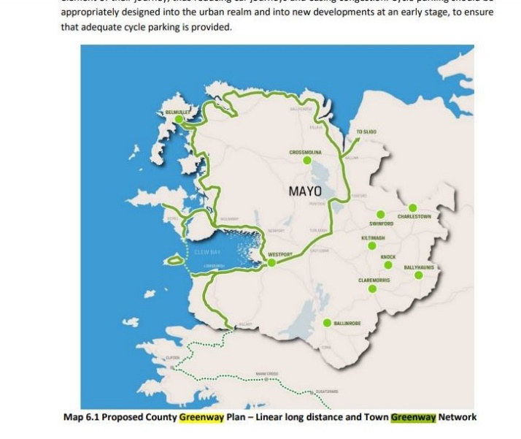 | 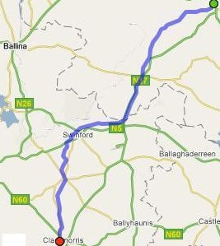

3 An appeal to the Ballina Municipal District Councillors to support the East Mayo Greenway and its connection to Ballina:

This is an open appeal to the following Ballina MD Cllrs: Annie Maye Reape, Jarlath Munnelly, John O’Hara, Mark Duffy, Michael Loftus and Seamus Weir.

In this submission The East Mayo Greenway group is openly addressing the members of Mayo county council that form the Ballina Municipal District and is asking them to support the East Mayo Greenway idea to be written into the Mayo county plan in 2021 and in turn to advocate the connection of the East Mayo Greenway to Ballina via an extension of the proposed Ballina to Foxford Greenway to Swinford.

We believe this simple idea will bring untold commercial benefit to the tourism industry of Ballina and its environs. The East Mayo greenway is fully supported by Irish Rail and The Department of Transport.

Both Irish Rail and the Department of Transport made submissions on the Mayo county plan in March of 2021 supporting the East Mayo Greenway on the Western Transport Corriodor from Claremorris to Charlestown. The support exists for this superb greenway facility in East Mayo and if this idea gets support of the Mayo councillors in the new county development plan we feel sure there will be central government support to connect the East Mayo Greenway with Ballina.

Please note that he Department of Transport re-named the closed railway from Collooney to Athenry as the “Western Transport Corridor” in the submission made on the Mayo county plan and fully endorsed the idea of a greenway on the route

We are asking councillors from the Ballina Municipal district to rethink the idea of the Western Transport Corridor and how it can be used to Ballina’s benefit for both rail and greenway

The Mayo section of the closed railway can be considered in two sections, we think it is critical for the Ballina Municipal district Cllrs to fully grasp this reality

- Section from the Galway county border at Milltown to Claremorris. This is part of the phase 2 and phase 3 sections of the Western Rail Corridor project, despite the fact the two independent reports found that the WRC from Athenry to Tuam and Tuam to Claremorris could not be justified under any circumstances, this part of the closed railway is still under consideration as part of the national rail review and may yet be re-opened as a railway at some time in the future. This is the section of the Western Transport corridor if re-opend for rail will connect Ballina to Athenry and to Foynes. The East Mayo Greenway group is not campaigning for this part of the Western Transport corridor to be converted to greenway and will fully accept the outcome of the National Rail Review
- The section of the closed railway from Claremorris to Collooney (Sligo) which is not being considered as part of the national rail review, it was not considered as part of the independent WRC review by EY consulting and Jaspers and is not under any consideration to re-open. There is already conversion of this route taking place for leisure purposes to prevent any further encroachment on the route. MCC has approved the Velorail project and got section 8 planning approval for the change of use at Kiltimagh and SCC is progressing with the Sligo Greenway project from Collooney to Bellaghy/Charlestown. East Mayo is facing the very real prospect of seeing a greenway terminate in Charlestown and nothing happening beyond Charlestown. All that will that achieve for East Mayo is that families in Charlestown, and visitors to the town from local town such as Ballina will go to Sligo to enjoy the benefits of this infrastructure.
IT IS SO IMPORTANT FOR BALLINA MD Cllrs to fully grasp the reality about the closed railway on the route from Claremorris to Charlestown and though Sligo to Collooney and ultimately to Enniskillen

Imagination is needed to take this one giant leap forward. The Sligo greenway is planned to extend through county Leitrim and Fermanagh to Enniskillen, and from Enniskillen through Cavan and to the East Coast Greenway. Just imagine if Ballina was connected to this network. If Charlestown was connected to Swinford and if a greenway could be created in the few miles from Swinford to Turlough House already connected to Castlebar, with a connector from Ballina- Foxford Greenway to Swinford In a few years’ time, Ballina could be connected to Achill and the East Coast by Greenway.

The East Mayo Greenway group is campaigning for a local facility that will make a local impact in terms of quality of life in East Mayo including Ballina; and make a regional and national impact in terms of the value of this greenway network to the tourism of the Atlantic Economic Corridor.

We appeal to the Ballina Municipal District cllrs to take this idea on board which will be of great benefit to East Mayo and does not threaten the idea of the western rail corridor from Ballina to Foynes.

East Mayo Greenway Committee on behalf of Group members
May 12th 2021

David Malee – Chairman
Michael Maye – PRO
Elizabeth Moore – Executive Secretary
Tom Lavin – Financial Officer.
eastmayogreenway@gmail.com

